

Properties and Structures of Materials
(Organic Chemistry)
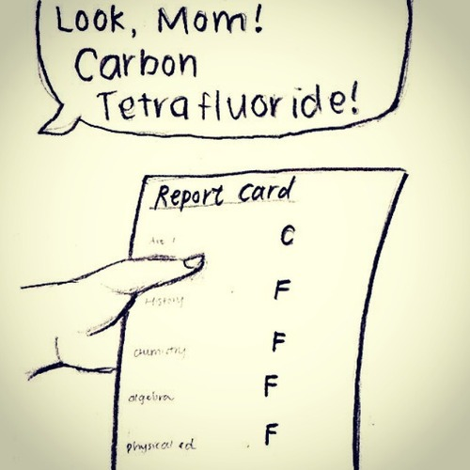

(AceOrganicChem.com n.d.)

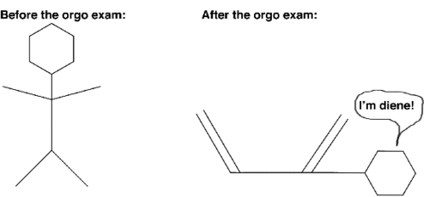

(Arboretictruth 2012)
Week | Outcomes | References and tasks | Tasks
8- 9 | - molecular structural formulae (condensed or showing bonds) can be used to show the arrangement of atoms and bonding in covalent molecular substances  - IUPAC nomenclature is used to name straight and simple branched alkanes and alkenes from C₁- C₈  - hydrocarbons, including alkanes, alkenes and benzene, have different chemical properties that are determined by the nature of the bonding within the molecules | Lucarelli Set 20,  q 1-7  Lucarelli Set 20,  q 11-12  Lucarelli Set 20,  q 8-10, 13-18
T1 w10-  T2 w1 | - alkanes, alkenes and benzene undergo characteristic reactions such as combustion, addition reactions for alkenes and substitution reactions for alkanes and benzene | Lucarelli Set 21,  q 1-8 | STAWA  Investigation 46  pg 108:  Reactivity of hydrocarbons  Task 5: Test- Properties and Structure of Materials: Organic Chemistry  (T2: Week 1)  Task 6: Practical test-Post laboratory test 1  (T2: Week 2)

Bonding in Organic Compounds
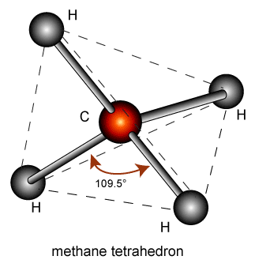
In organic compounds, carbon is covalently bonded to other non-metals. Carbon has four valence electrons needing four electrons to achieve a stable octet and so forms four covalent bonds. These bonds can be single, double or triple. For example, the “simplest” organic compound is methane (CH₄).

(NA, 2009)
The carbon atom shares one each of its valence electrons with a hydrogen atom. The molecule is actually tetrahedral in shape so as to minimise the repulsion between the four single C-H bonds.

Hydrocarbons are molecular compounds containing the elements hydrogen and carbon. They are classified into various families of compounds based on structural similarities. We will study the families of:
- Alkanes
- Alkenes
- Cycloalkanes
- Cycloalkenes
- Benzene based compounds (aromatics)

Nomenclature (Naming)
- Find the longest continuous carbon chain. Choose the stem name based on the number of carbon atoms in the longest continuous carbon chain.

Number of Carbons | Stem Name
One | meth-
Two | eth-
Three | prop-
Four | but-
Five | pent-
Six | hex-
Seven | hept-
Eight | oct-
Nine | non-
Ten | dec-

- Number the carbon atoms sequentially so that the principle functional group has the lowest number.
The order of priority of the principle functional groups is (from highest to lowest): alkene; halogen then alkyl groups.

For example: CH₃CH₂CH=CHCH₃ pent-2-ene

- If there is a substituted group (eg a halogen), number the carbons from the end which gives the lowest number to the substituted group.
For example: CH₃CH₂CHCH₃ 2-chlorobutane
Cl
- If there is an alkyl group (other carbon atoms not part of the main chain – also called a branch), name this using the stem name for the number of carbons and use the suffix -yl. Put a number in front to indicate which carbon it comes from then write the stem name.
For example: -CH₃ methyl-
-CH₂CH₃ ethyl-
CH₃CH₂CH₂CHCH₂CH₃ 3-ethylhexane
CH₂
CH₃
CH₂CHCH=CHCH₃ 4-methylpent-2-ene
CH₃

- If there is more than one of a substituted group, write the numbers to indicate which carbon they come off, then follow with the prefix di, tri, tetra, penta, etc, then the branch name and -yl. Always finish with the straight chain name.
For example: CH₃CHCH₂CHCH₂CH₃
CH₃ CH₃ 2,4-dimethhylhexane

- Note that numbers are separated from words by hyphens and numbers are separated from each other by commas. There should be no spaces or capital letters in the name at all (unless it is the beginning of a sentence).

- If there are different types of alkyl groups in the same chain, again use numbers, and put the alkyl groups in alphabetical order according to the stem name (note: you disregard the numerical prefix when alphabetizing).
For example: CH₃CH CH CH CH₂CH₃
CH₃ CH₃ CH₂
CH₃ 4-ethyl-2,3-dimethylhexane
- there are substituted halogens, the same rules apply as for alkyl groups, but use fluoro-, chloro-, bromo- and/or iodo-. Again, substituted groups are named alphabetically.
For example: CH₃CH₂CH₂CHCHCH₃
Cl F 3-chloro-2-fluorohexane

- If there are alkyl groups and substituted halogens, name the halogens before the alkyl groups. If the lowest numbers occur by counting from either end, number so the halogen gets the lowest number. In the case of a tie between two halogens, the first alphabetically gets the lowest number.
For example: CH₃CH CH CH CHCH₃
CH₃ CH₃ Cl Cl 2,3-dichloro-4,5-dimethylhexane

- If there is only one option for a substituted halogen or alkyl groups, do not use numbers.
For example: CH₃CHCH₃
CH₃ methylpropane

CH₃CH₂Cl chloroethane

Cycloalkanes
- The name begins with the prefix cyclo- to distinguish it from straight chain aliphatics.
- Note the shorthand way of drawing rings, where each corner represents a carbon. It is assumed that the remaining bonds are between the carbon and hydrogen atoms.
- If there is one substituted group, no numbering is required. If there is more than one, numbering is required.
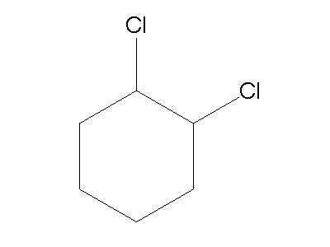
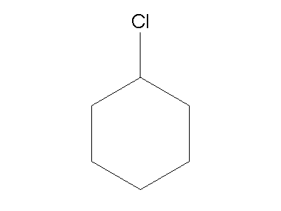
Chlorocyclohexane 1,2-dichlorocyclohexane

Cycloalkenes
- Cycloalkenes are named similar to the cycloalkanes (ie add the prefix cyclo-) and the double bond is given the lowest number position.

Benzene
- Benzene and its derivatives are named similar to cyclic hydrocarbons, but ending with the suffix –benzene.
Alkanes
Alkanes are saturated, they contain only single bonds between carbon atoms.
Name | Molecular formula | Structural formula | Condensed formula
 | C₂H₆
Butane

 |  |  | CH₃CH(CH₃)CH₂CH₃
 |  | 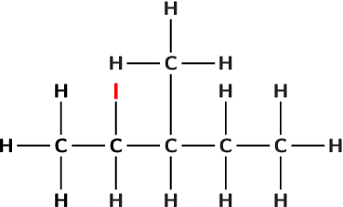

Alkanes: Structural isomerism
Structural isomers are compounds having the same molecular formula but different structural formula.
Draw the three structural isomers of C₅H₁₂. Name them and write their condensed formula.

Alkenes
Alkenes contain a double bond between carbon atoms and so are unsaturated.
Name | Molecular formula | Structural formula | Condensed formula
 | C₂H₄
 |  |  | CH₃CH₂CHCHCH₃
3,4-diethylhex-1-ene

Alkenes: Geometric (cis-trans) isomerism
Geometric isomers have the same molecular and structural formula but a different geometry. The different geometry is a result of the inability of double bonded carbon atoms to rotate along the axis of their double bond.
Draw the cis and trans isomers of but-2-ene.

Cycloalkanes
Name | Molecular formula | Structural formula | Condensed formula
 |  |  | CH₂CH₂CH₂
1,2-dichlorocyclohexane

 |  | 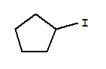

Cycloalkenes
Name | Molecular formula | Structural formula | Condensed formula
 |  |  | CHCHCH₂
4-chlorocyclohexene

 |  | 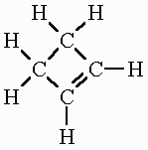

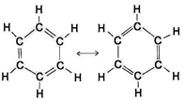
Benzene compounds- aromatics
These are the hydrocarbons containing the benzene ring.
The benzene ring has the formula C₆H₆ and is particularly stable.

Due to the arrangement of its electrons, the benzene ring is represented as follows:
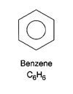

Name | Molecular formula | Structural formula | Condensed structural formula
methylbenzene

 |  |  | (CH)₃CClCHCCl
 |  | 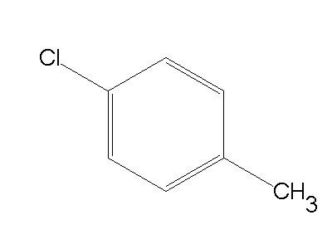

Physical Properties of Hydrocarbons
- Melting and Boiling Points

- Solubility

Chemical Properties of Hydrocarbons

- Addition
As alkenes are unsaturated, they have the capacity to bond to more atoms. They are therefore more reactive than alkanes and readily undergo addition reactions.
Use condensed structural formula to show the addition reactions for:
- Pent-1-ene + hydrogen
- Pent-1-ene + fluorine
- Pent-1-ene + Hydrogen chloride

- Substitution
Substitution reactions occur when an alkane or benzene is combined with another element. The C-H bond breaks and the hydrogen is substituted with another element which requires one bond, for example a halogen.
The reactions tend to be slow with one substitution at a time and they require UV light as a catalyst.
Use condensed structural formula to show the substitution reactions for:
- Ethane + bromine (first substitution)
- Methane + chlorine (complete substitution)
- Benzene + Cl₂

- Combustion
Hydrocarbons are excellent fuels. When ignited in excess air (O₂) they produce carbon dioxide and water vapour and also release considerable amounts of heat energy. This is called complete combustion.
Use molecular formula to write balanced chemical equations for the following combustion reactions (assume complete combustion):
- Methane in air
- Butane in air

Incomplete combustion will occur if the air (O₂) supply is limited. Carbon monoxide and even soot (solid carbon) can be produced.
Use molecular formula to write balanced chemical equations for the following reactions where incomplete combustion occurs:
- Methane in limited oxygen
- Butane in limited oxygen

Bibliography
AceOrganicChem.com. One more organic chemistry joke. n.d. http://www.aceorganicchem.com/blog/2013/10/04/one-organic-chemistry-joke/ (accessed March 16, 2015).
Arboretictruth. Nerd Humour. 13 June 2012. https://arboretictruth.wordpress.com/2012/06/13/nerd-humor/ (accessed March 16, 2015).
NA. (2009). The Conformation and Configuration of Polymer Molecules. Retrieved October 10th, 2009, from Beechmont Crest

